**CSA1086 - Software Engineering**

GitHub Repository Cloning

STEP 1: Open your github repository

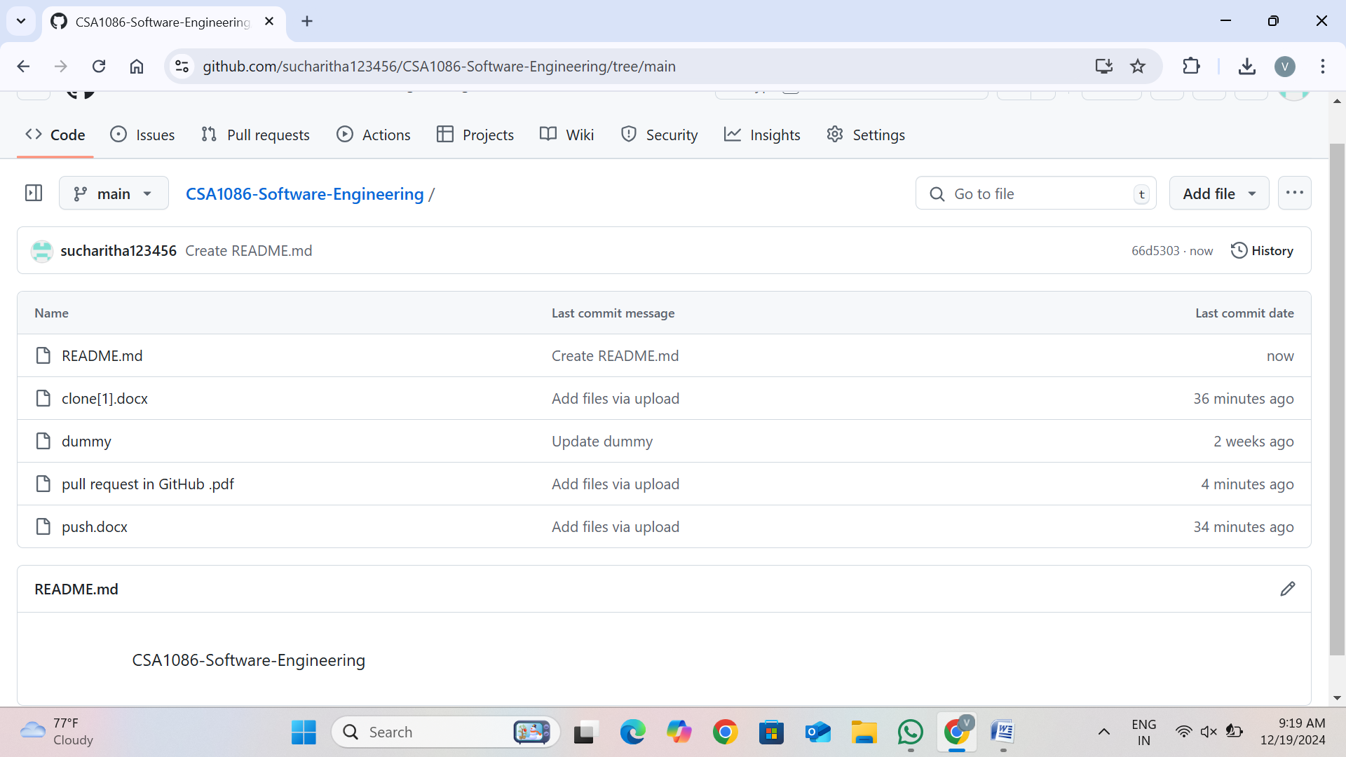

STEP 2: Copy http url of your git repository

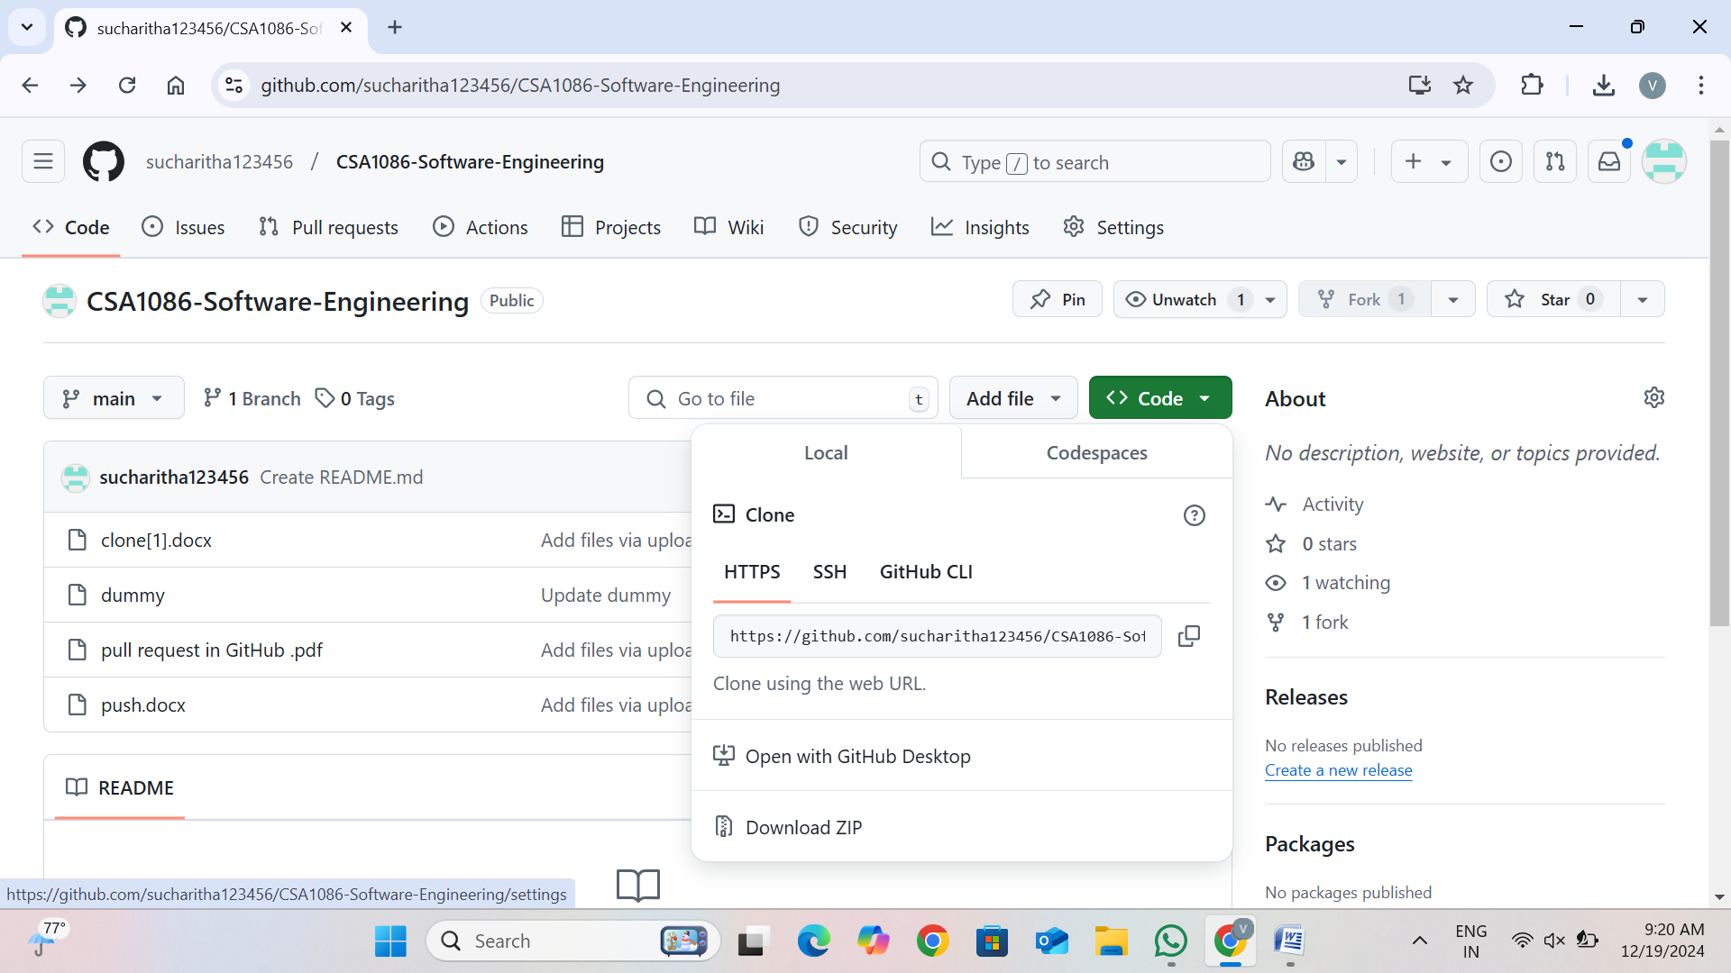

STEP 3: Open Git bash in the folder of your device where you want to clone the repository

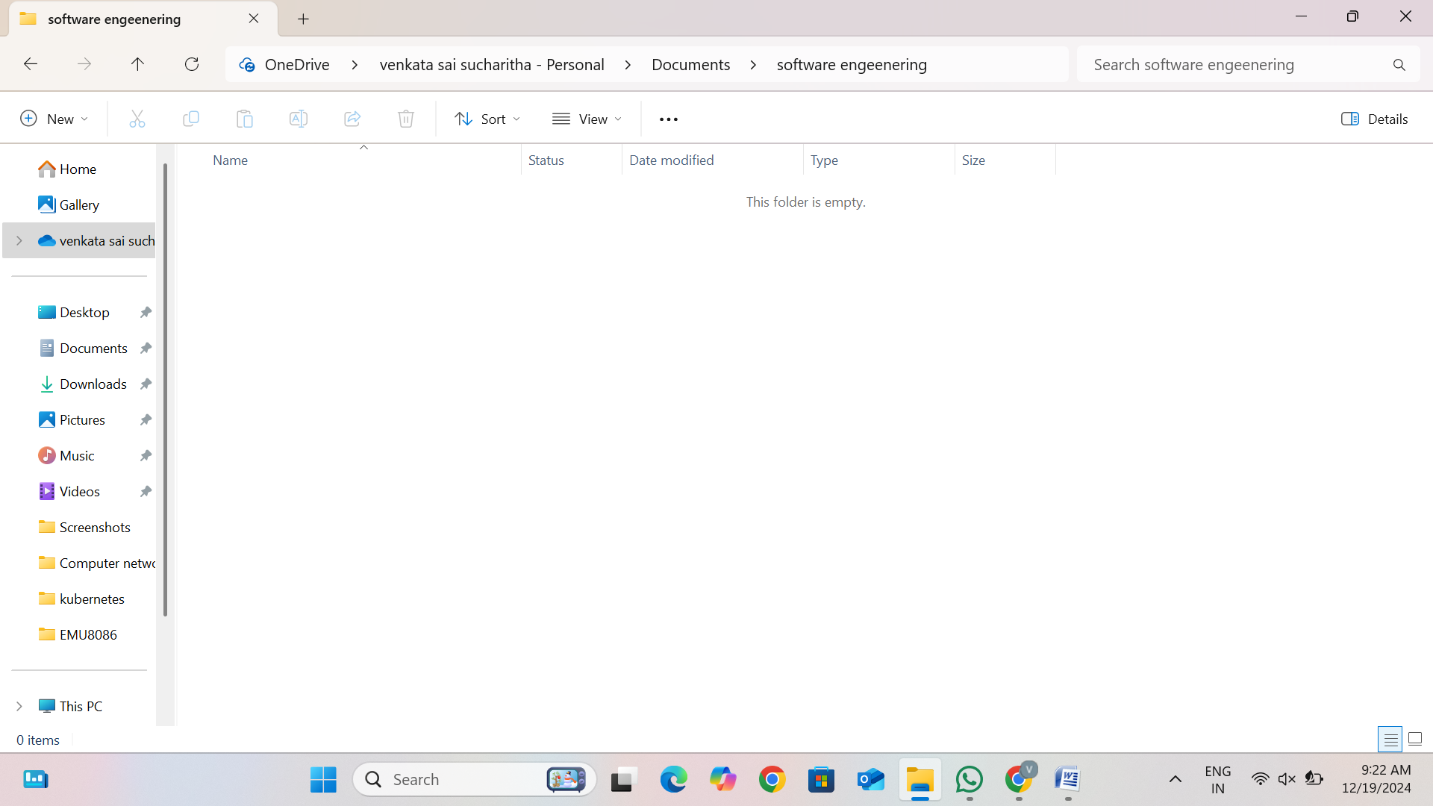

STEP 4: Type : git clone <git repository http url> and press enter

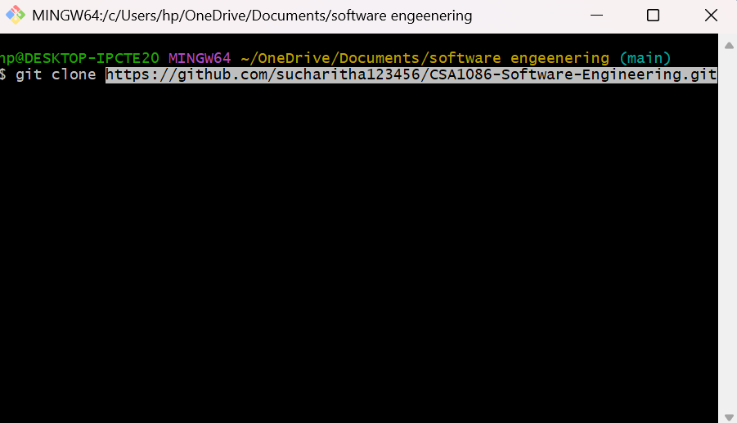

STEP 5: Your repository has been cloned

